

School of Engineering and
Technology



Fundamentals Of Operating
System Lab
Lab Assignment
ENCA252
For
BCA(AI & DS)
(2026-27)

Prepared by Vikram Submitted To : Dr. Sneh Yadav
Roll No : 2401201217
Problem Title:
Implementation of Banker’s Algorithm for Deadlock Avoidance
Problem Statement
Deadlock is a situation in operating systems where a set of processes are unable to proceed because each is waiting for resources held by others. Banker’s Algorithm is a deadlock avoidance technique that ensures the system remains in a safe state. In this assignment, students will implement Banker’s Algorithm and determine whether the system is in a safe state, as well as find the safe sequence of execution.
Learning Objectives
- Understand CPU scheduling concepts
- Implement FCFS and SJF algorithms
- Calculate CT, TAT, WT
- Analyze system performance
Tools/Technology Used:
- Python 3.x
- Built-in Python libraries: os, multiprocessing, time
- Linux OS (optional for simulation)

Assignment Tasks:
Task 1: System Input and Data Representation
Objective:
To understand how resources are allocated to processes in an operating system.
Description:
Students will input system data including number of processes, number of resources, allocation matrix, maximum matrix, and available resources.
Sub-Tasks:
  - Define number of processes and resources.
  - Input Allocation Matrix.
  - Input Maximum Matrix.
  - Input Available Resources.

Expected Outcome:
· Understanding of system resource allocation
· Ability to represent system state
Input :

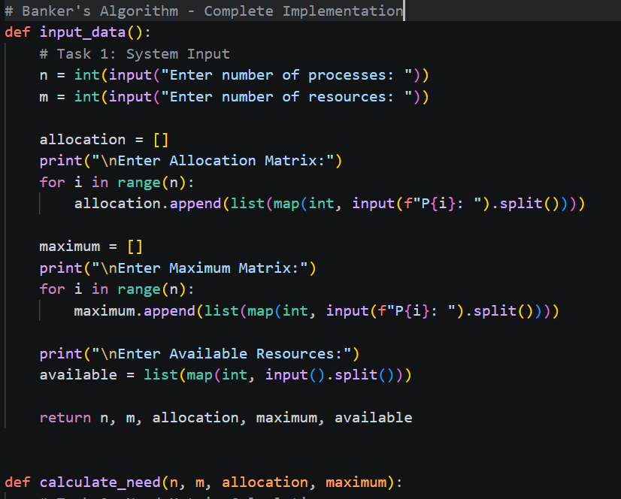

Output :
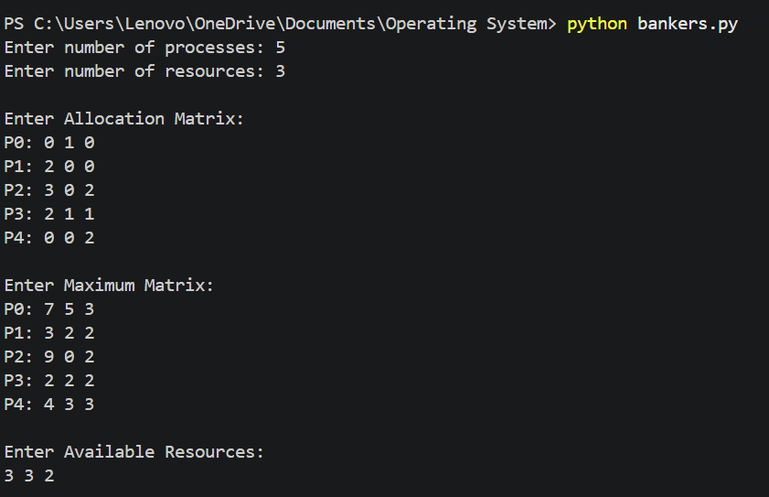

Task 2: Need Matrix Calculation
Objective:
To compute the remaining resource requirements for each process.
Description:
Need Matrix is calculated using the formula:
Need = Maximum – Allocation Sub-Tasks:
  - Calculate Need Matrix.
  - Display the Need Matrix.
Expected Outcome:
· Clear understanding of process requirements
· Ability to derive required resources

Input :
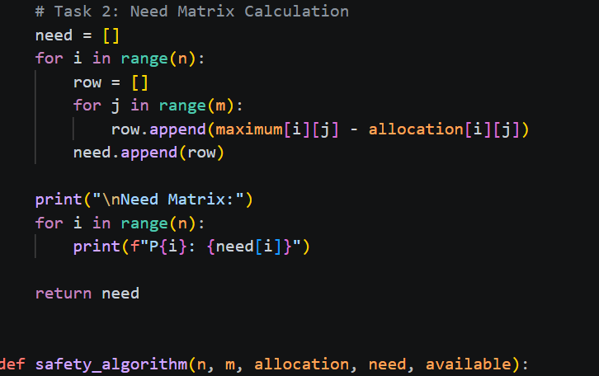

Output :

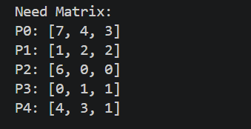

Task 3: Banker’s Safety Algorithm Implementation
Objective:
To determine whether the system is in a safe state.
Description:
The safety algorithm checks if there exists a safe sequence in which all processes can execute without causing deadlock.
Sub-Tasks:
  - Initialize Work = Available.
  - Initialize Finish array for all processes.
  - Find a process whose Need ≤ Work.
  - Allocate resources and update Work.
  - Repeat until all processes are completed or no further allocation is possible.
Expected Outcome:
· Ability to check safe/unsafe state
· Understanding of deadlock avoidance
Input :
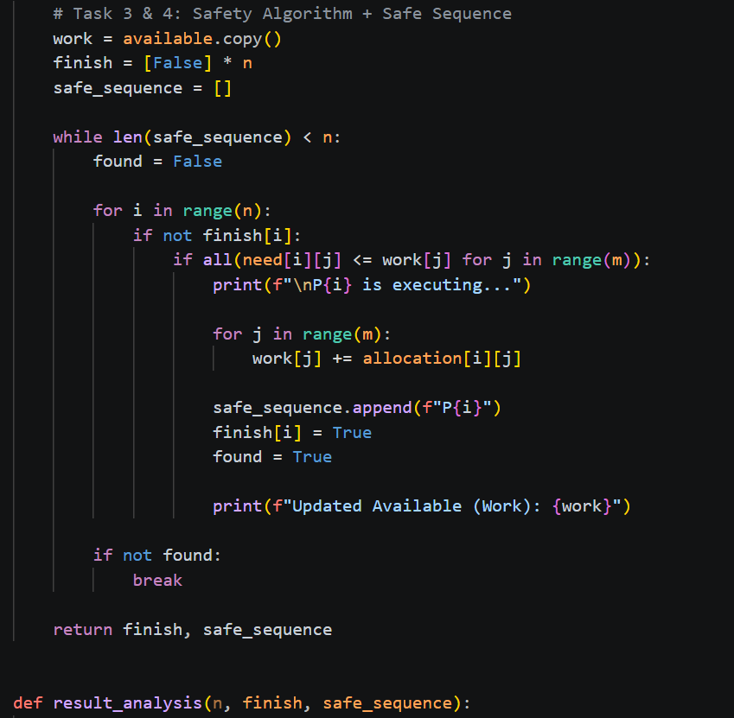
Output :
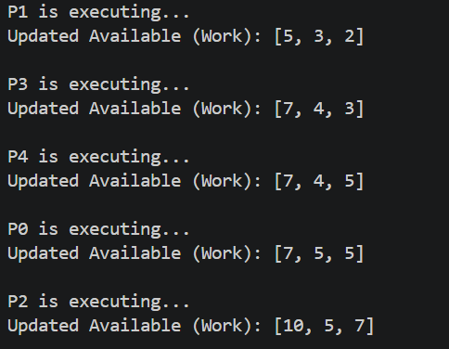

Task 4: Safe Sequence Determination
Objective:
To find the safe execution order of processes.
Description:
If the system is in a safe state, a sequence of execution is generated.
Sub-Tasks:
- Store processes in safe sequence.
- Display the safe sequence.
Expected Outcome:
· Understanding of execution order
· Visualization of safe process flow

Input :


Output :

Task 5: Result Analysis
Objective:
To analyze system safety and interpret results.
Description:
Students will evaluate whether the system is safe or unsafe and justify their results.
Sub-Tasks:
- Identify whether the system is in safe or unsafe state.
- Explain the result.
- Compare with theoretical expectations.
Expected Outcome:
· Analytical thinking
· Understanding of real-world deadlock scenario
Input :
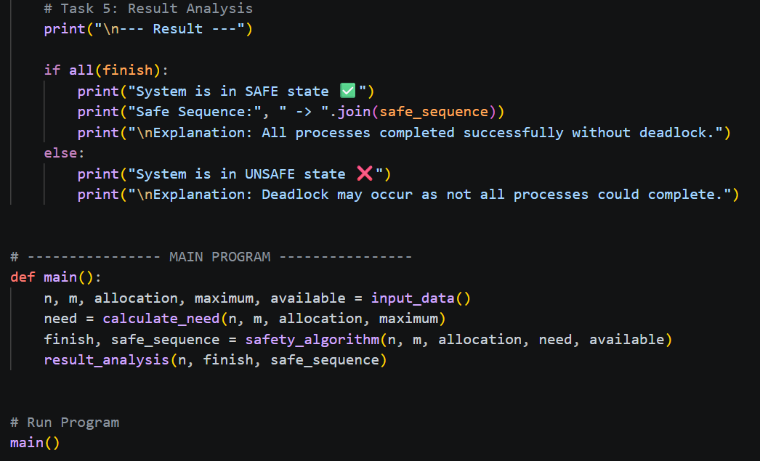
Output :

